**Q1. How is Kubernetes different from Docker Swarm?**

|  |  |  |
| --- | --- | --- |
| **Features** | **Kubernetes** | **Docker Swarm** |
| **Installation & Cluster Config** | Setup is very complicated, but once installed cluster is robust. | Installation is very simple, but the cluster is not robust. |
| **GUI** | GUI is the Kubernetes Dashboard. | There is no GUI. |
| **Scalability** | Highly scalable and scales fast. | Highly scalable and scales 5x faster than Kubernetes. |
| **Auto-scaling** | Kubernetes can do auto-scaling. | Docker swarm cannot do auto-scaling. |
| **Load Balancing** | Manual intervention needed for load balancing traffic between different containers and pods. | Docker swarm does auto load balancing of traffic between containers in the cluster. |
| **Rolling Updates & Rollbacks** | Can deploy rolling updates and does automatic rollbacks. | Can deploy rolling updates, but not automatic rollback. |
| **DATA Volumes** | Can share storage volumes only with the other containers in the same pod. | Can share storage volumes with any other container. |
| **Logging & Monitoring** | In-built tools for logging and monitoring. | 3rd party tools like ELK stack should be used for logging and monitoring. |

**Q2. What is Kubernetes?**

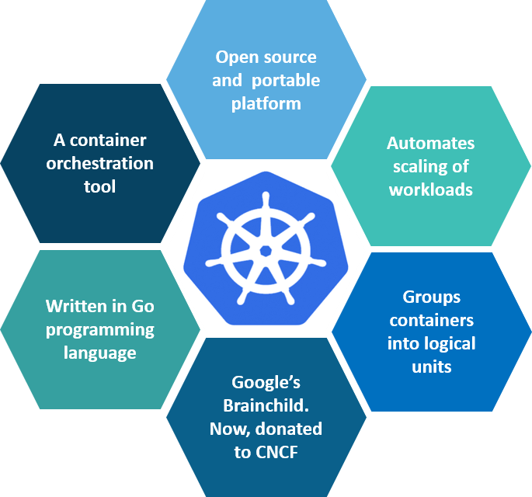

**Fig 1:** What is Kubernetes – Kubernetes Interview Questions

Kubernetes is an open-source container management tool which holds the responsibilities of container deployment, scaling & descaling of containers & load balancing. Being the Google’s brainchild, it offers excellent community and works brilliantly with all the cloud providers. So, we can say that Kubernetes is not*a containerization platform, but it is a multi-container management solution.*

**Q3. How is Kubernetes related to Docker?**

It’s a known fact that Docker provides the lifecycle management of containers and a Docker image builds the runtime containers. But, since these individual containers have to communicate, Kubernetes is used.  So, Docker builds the containers and these containers communicate with each other via Kubernetes. So, containers running on multiple hosts can be manually linked and orchestrated using Kubernetes.

**Q4. What is the difference between deploying applications on hosts and containers?**

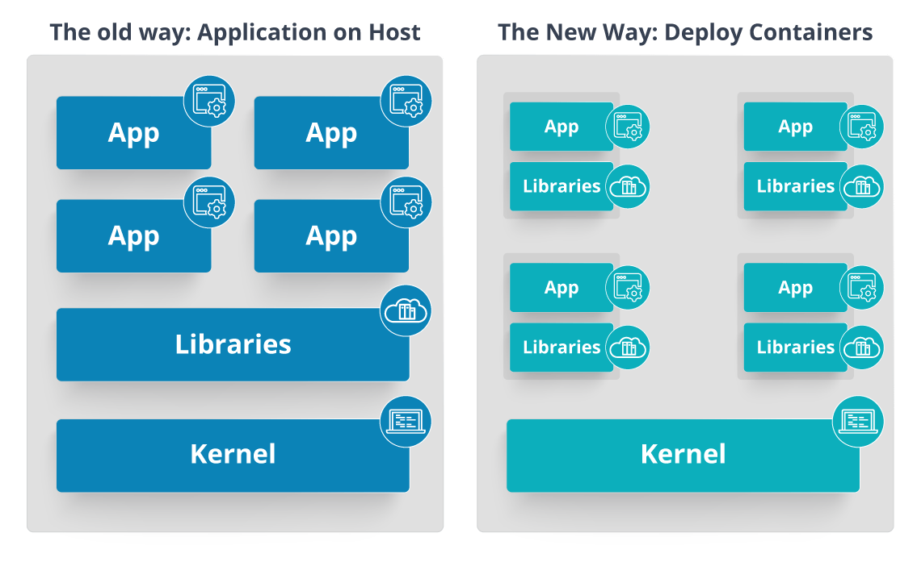

**Fig 2:** Deploying Applications On Host vs Containers

Refer to the above diagram. The left side architecture represents deploying applications on hosts. So, this kind of architecture will have an operating system and then the operating system will have a kernel which will have various libraries installed on the operating system needed for the application. So, in this kind of framework you can have n number of applications and all the applications will share the libraries present in that operating system whereas while deploying applications in containers the architecture is a little different.

This kind of architecture will have a kernel and that is the only thing that’s going to be the only thing common between all the applications. So, if there’s a particular application which needs Java then that particular application we’ll get access to Java and if there’s another application which needs Python then only that particular application will have access to Python.

The individual blocks that you can see on the right side of the diagram are basically containerized and these are isolated from other applications. So, the applications have the necessary libraries and binaries isolated from the rest of the system, and cannot be encroached by any other application.

**Q5. What is Container Orchestration?**

Consider a scenario where you have 5-6 microservices for an application. Now, these microservices are put in individual containers, but won’t be able to communicate without container orchestration. So, as orchestration means the amalgamation of all instruments playing together in harmony in music, similarly container orchestration means all the services in individual containers working together to fulfill the needs of a single server.

**Q6. What is the need for Container Orchestration?**

Consider you have 5-6 microservices for a single application performing various tasks, and all these microservices are put inside containers. Now, to make sure that these containers communicate with each other we need container orchestration.

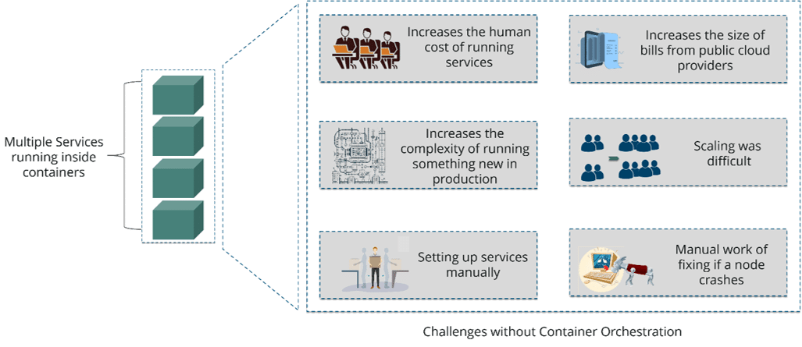

**Fig 3:** Challenges Without Container Orchestration – Kubernetes Interview Questions

As you can see in the above diagram, there were also many challenges that came into place without the use of container orchestration. So, to overcome these challenges the container orchestration came into place.

**Q7. What are the features of Kubernetes?**

The features of Kubernetes, are as follows:

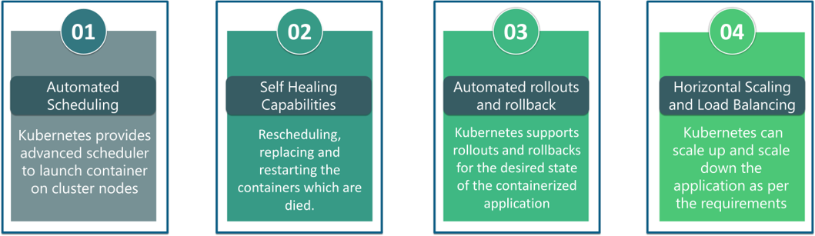

**Fig 4:** Features Of Kubernetes – Kubernetes Interview Questions

**Q8. How does Kubernetes simplify containerized Deployment?**

As a typical application would have a cluster of containers running across multiple hosts, all these containers would need to talk to each other. So, to do this you need something big that would load balance, scale & monitor the containers. Since Kubernetes is cloud-agnostic and can run on any public/private providers it must be your choice simplify containerized deployment.

**Q9. What do you know about clusters in Kubernetes?**

The fundamental behind Kubernetes is that we can enforce the desired state management, by which I mean that we can feed the cluster services of a specific configuration, and it will be up to the cluster services to go out and run that configuration in the infrastructure.

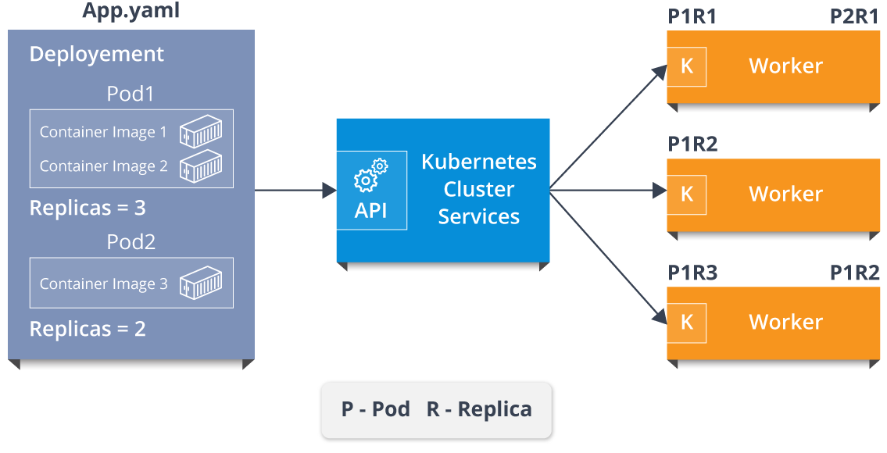

**Fig 5:** Representation Of Kubernetes Cluster – Kubernetes Interview Questions

So, as you can see in the above diagram, the deployment file will have all the configurations required to be fed into the cluster services. Now, the deployment file will be fed to the API and then it will be up to the cluster services to figure out how to schedule these pods in the environment and make sure that the right number of pods are running.

So, the API which sits in front of services, the worker nodes & the Kubelet process that the nodes run, all together make up the Kubernetes Cluster.

**Q10. What is Google Container Engine?**

**Google Container Engine (GKE)**is an open source management platform for Docker containers and the clusters. This Kubernetes based engine supports only those clusters which run within the Google’s public cloud services.

**Q12.  What is Minikube?**

Minikube is a tool that makes it easy to run Kubernetes locally. This runs a single-node Kubernetes cluster inside a virtual machine.

**Q13.  What is** **Kubectl?**

Kubectl is the platform using which you can pass commands to the cluster. So, it basically provides the CLI to run commands against the Kubernetes cluster with various ways to create and manage the Kubernetes component.

**Q14.  What is Kubelet?**

This is an agent service which runs on each node and enables the slave to communicate with the master. So, Kubelet works on the description of containers provided to it in the PodSpec and makes sure that the containers described in the PodSpec are healthy and running.

**Q15. What do you understand by a node in Kubernetes?**  
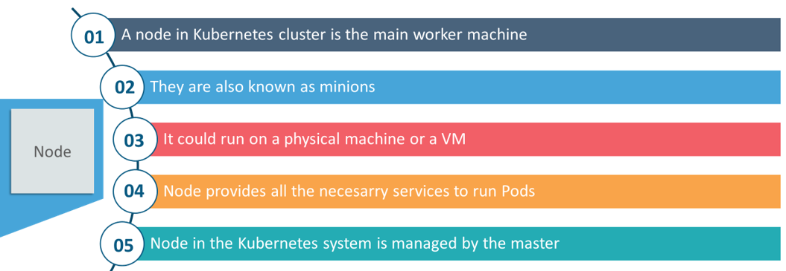

**Fig 6:**Node In Kubernetes – Kubernetes Interview Questions

### ****Q16. What are the different components of Kubernetes Architecture?****

The Kubernetes Architecture has mainly 2 components – the master node and the worker node. As you can see in the below diagram, the master and the worker nodes have many inbuilt components within them. The master node has the kube-controller-manager, kube-apiserver, kube-scheduler, etcd. Whereas the worker node has kubelet and kube-proxy running on each node.

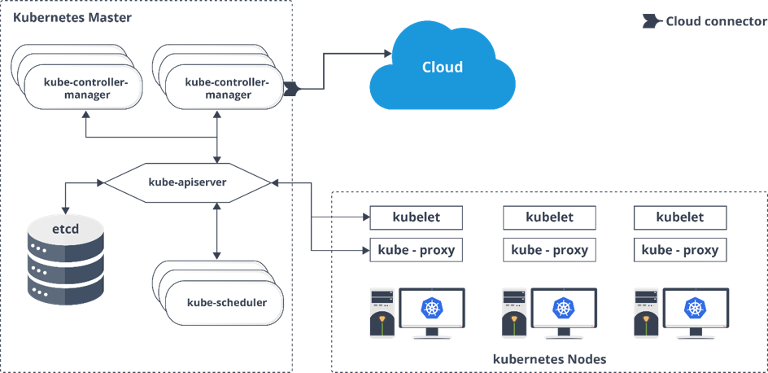

### ****Q17. What is the role of kube-apiserver and kube-scheduler?****

The kube – apiserver follows the scale-out architecture and, is the front-end of the master node control panel. This exposes all the APIs of the Kubernetes Master node components and is responsible for establishing communication between Kubernetes Node and the Kubernetes master components.

The kube-scheduler is responsible for distribution and management of workload on the worker nodes. So, it selects the most suitable node to run the unscheduled pod based on resource requirement and keeps a track of resource utilization. It makes sure that the workload is not scheduled on nodes which are already full.

### ****Q18. What are the best security measures that you can take while using Kubernetes?****

The following are the best security measures that you can follow while using Kubernetes:

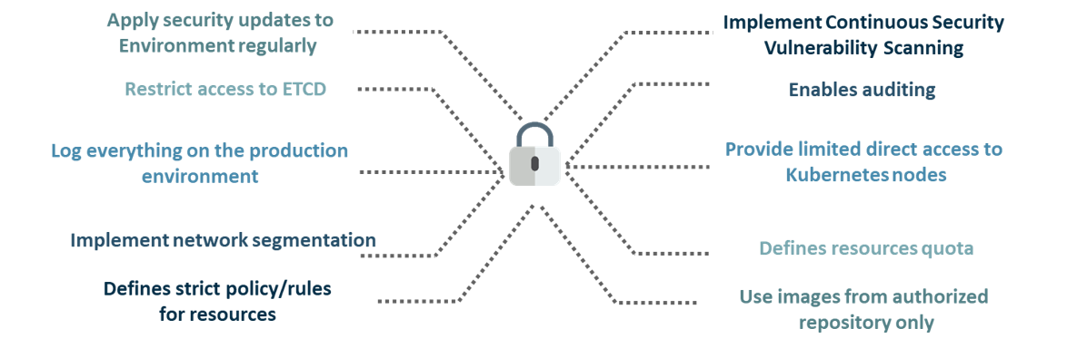

**Fig 14:** Best Security Measures